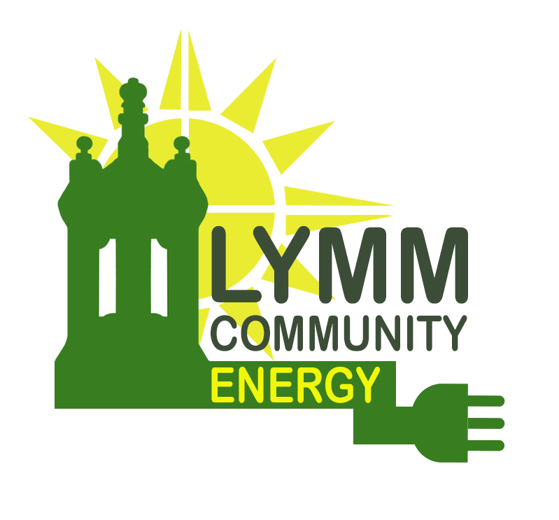

Community Benefit Fund (CBF) 2025 - 2026
Application Form
(Please read the Guidance document before completing this form)
Applications can be accepted at any time, but once all funds have been allocated, this round of funding will be closed to new applicants. Funds will be allocated to eligible bids on a first come, first served basis.
- Please provide details of your organisation as follows:
Organisation name:
Address:
Contact name:
Contact position in organisation:
Contact telephone/mobile number:
Contact email address:
- Please provide details of your legal status (e.g. charity, club, society, community interest company, company limited by guarantee, limited company) and company or charity number where applicable:

- Please provide a short description of the organisation’s main activities (50 words maximum):

- What are the objectives and scope of the project to be funded (150 words maximum)?

- How will you deliver the project? Please give details of your work programme and timetable (300 words maximum):

- Who will manage and work on the project? What is their experience of similar projects? (250 words maximum):

- What will be the project results, outcomes and community benefits and how will they be measured? (250 words maximum):

- What lessons do you expect to learn from implementing the project? (250 words maximum):

- How will you disseminate the results and lessons learnt? (150 words maximum):

- What will be the total cost of the project? Please provide a breakdown of the costs into main items of expenditure with supporting evidence:

- How much are you requesting from the CBF? Please provide details of other sources of funding which have been secured for the project where applicable:

- Please provide any supporting evidence separately (e.g. quotes for key items of expenditure, recent accounts, expressions of support etc)

Name:
Position in organisation:
Date

Please email your completed form to info@lymmcommunityenergy.org.uk Alternatively you can post it to: Lymm Community Energy, 1, Dyers Close, Lymm WA13 9QJ. This is a rolling programme and applications can be made any time. Funding bids will be assessed on a first-come, first-served basis. Once all funds have been allocated, the funding round will close and no further applications will be received. If you have any questions about your application, please contact Rachel Waggett, Lymm Community Energy on 07711 804556 or 01925 751683.

